**DSP Assignment 2 (Fall 2020) – 5Th Semester**

**CLO-2**

Compute and plot the convolution x[n]*h[n] and h[n]*x[n] for the pair of signals shown in Figure 1, below.



**Figure 1**

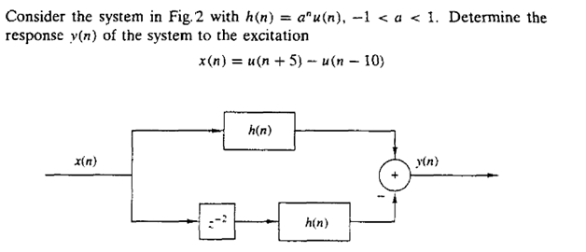

**Figure 2**

This assignment is due on Friday 1st January, 2021 and its associated quiz will also be on Friday 1st January, 2021.